Week : 6/1/2020 to 6/5/2020 |  |  | Topic: Plank challenge
Class Activity : Time: 20 + minutes |  |  | Equipment :  Timer
Class – Objectives
Wilf:
Students will attempt to perform an exercise plank to see if they can hold a plank for X amount of time. Students will try to achieve levels of success by performing the plank for that time period that goes with each level.

Gross Motor:  Students will use their muscles to support the weight of their body when holding a plank |  | Cognitive :  Students will focus mentally on the task by breathing and using correct body form
Time | Lesson Instructions |  |  | Student expectations
20 min | - Student Plank challenge for all grades  Activity  Link: Watch plank video to learn how to place your body.  https://www.youtube.com/watch?v=TvxNkmjdhMM  - Choose the type of plank you want to use  - Half plank  - Full plank  - See examples below  Plank Levels: Try to accomplish each level during the week  - Level 1: 30 second  - Level 2: 1 minute  - Level 3: 2 minutes  - Level 4: 3 minutes  - Level 5: 5 minutes  - Level 6: 7 minutes  - Level 7: 10 minutes or more  Example of Half and full plank  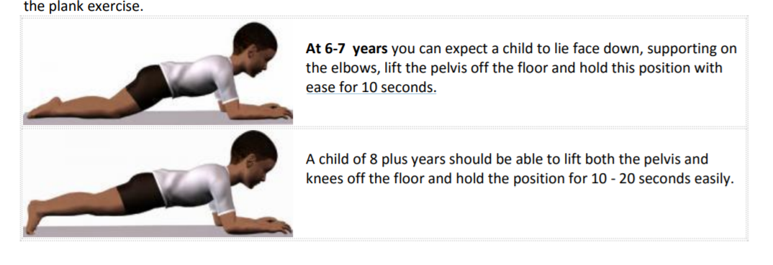  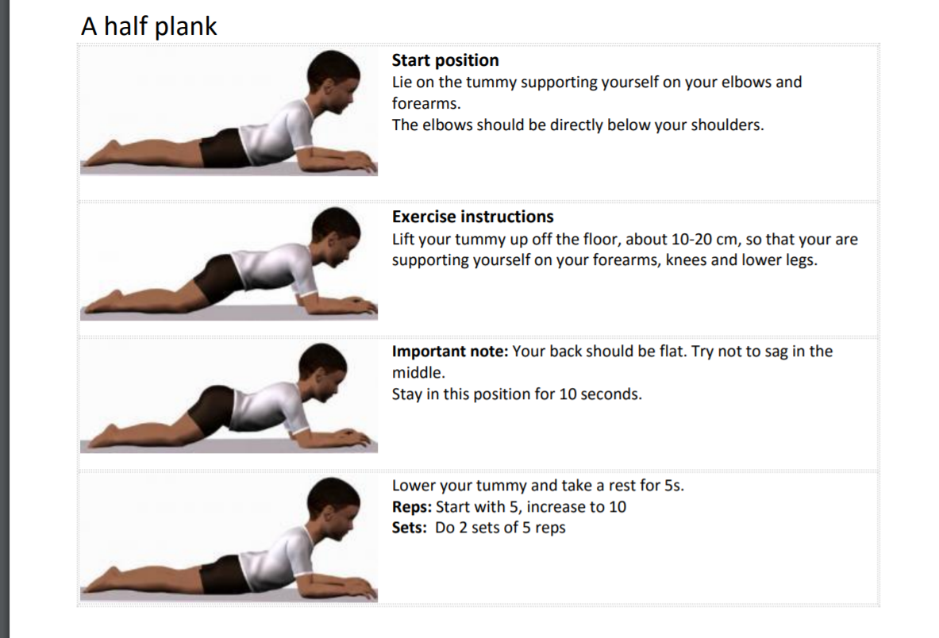  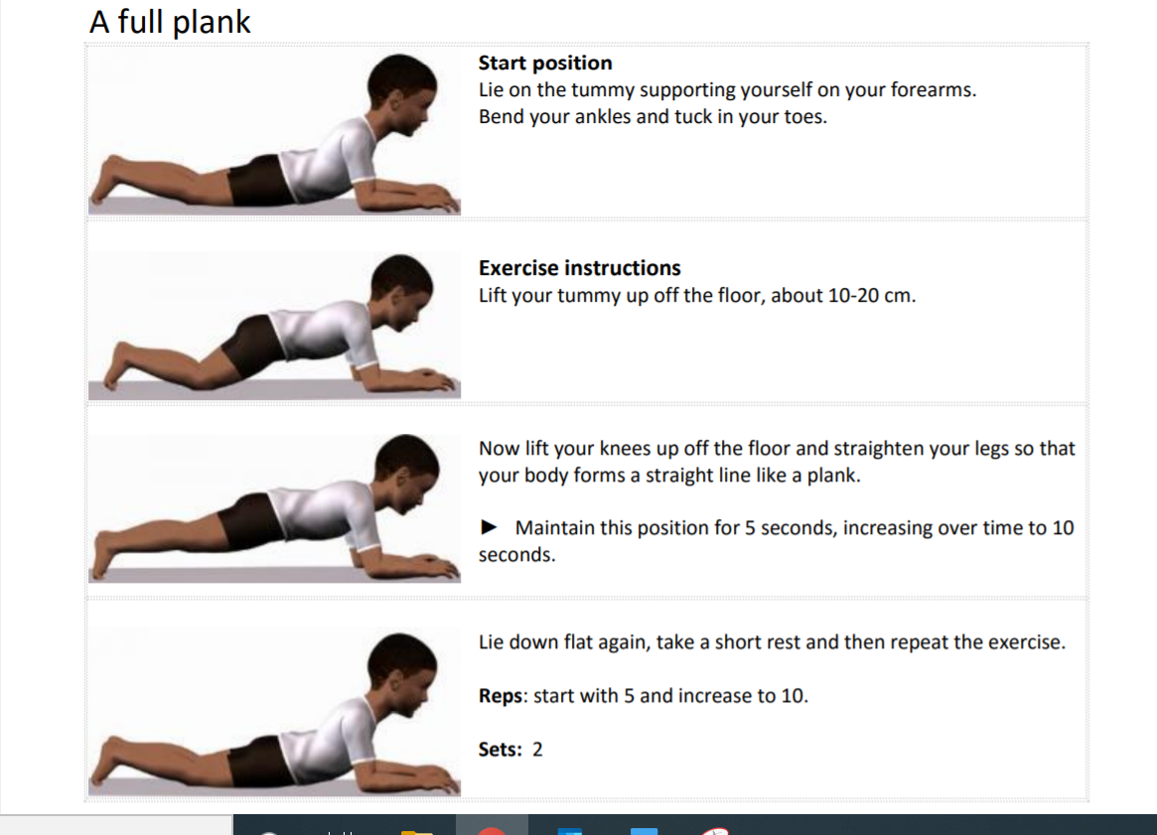  More challenging: 3rd to 5th  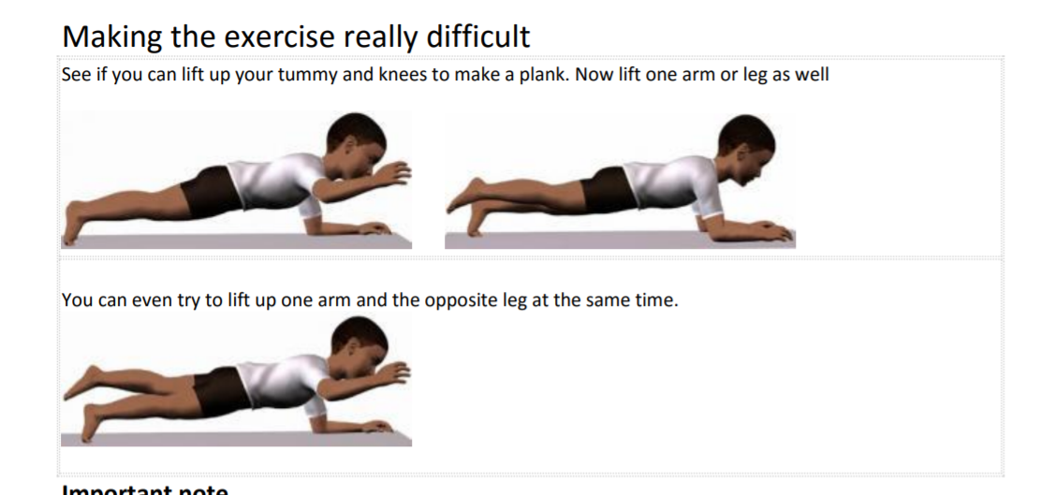  - Students will ask a parent or sibling to time them to see if they can perform a plank and try to pass the levels.  Have fun |  |  | Students will attempt to achieve levels during the week

